**Nevada Reading Week 2024**

**Art Contest: Grades 3-12**

**Theme: Embrace the Magic of Reading**

We need your participation to make Nevada’s Reading Week 2024 a huge success!

**Details:** Enter by uploading a drawing or graphic design (must be in pencil or black ink) on one 8 X 11.5 inch or 9 x 12 inch piece of white paper. The design must contain the **exact** words of this year’s theme, *Embrace the Magic of Reading.* Each submission will be scored using this rubric.

The grand prize winner will work with a graphic designer to select logo colors. The logo will be used statewide for apparel, social media, etc. Please keep your original art until winners are announced. For additional information please go to [www.nevadareadingweek.org](http://www.nevadareadingweek.org) and reach out to [info@nevadareadingweek.org](mailto:info@nevadareadingweek.org) with any questions.

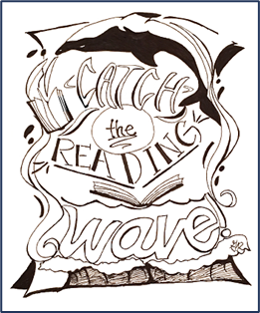

**Virtual Award Ceremony November 28th:** The Nevada Reading Week Committee will recognize and award winners and the teacher of the grand prize recipient.

* Grand Prize Winner: Certificate and $150 gift card
* Elementary School Honorable mention: Certificate and $75 gift card
* Middle School Honorable mention: Certificate and $75 gift card
* High School Honorable mention: Certificate and $75 gift card

**Submission Information**

Submit your original logo design by September 29th

via a picture or upload to [readingweekartcontest2023@washoeschools.net](mailto:readingweekartcontest2023@washoeschools.net) with the following

information included:

Student’s First and Last Name _____________________ Email: _______________________

School _____________________________   Grade__________

Teacher’s First and Last Name ____________________

Teacher’s Email: ___________________________